**Class Project 2**

Use two images for each operation to do the following operations and write down their advantages and disadvantages and explain your results:

1. **Image Sharpen (lena, bridge):**

* Laplacian

**Algorithm:**

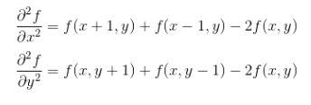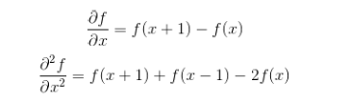

Combine the two function:



i=1, i < imageheight-1, i plus 1

j = 1, j < imagewidth-1, j plus 1

$$value=inimagedata\left[j+1\right]\left[i\right]+inimagedata\left[j-1\right]\left[i\right]+inimagedata\left[j\right]\left[i+1\right]+inimagedata\left[j\right]\left[i-1\right]-4*inimagedata\left[j\right]\left[i\right]$$

If $inimagedata\left[j\right]\left[i\right]-value$ is smaller than 0

$outimagedata\left[j\right]\left[i\right]=0$

If $inimagedata\left[j\right]\left[i\right]-value$ is bigger than 255

$outimagedata\left[j\right]\left[i\right]=255$

otherwise

$outimagedata=inimagedata\left[j\right]\left[i\right]-value$

**Results (including pictures):**

Result of processing “Lena.pgm”:

Source Image: Result after image sharpen: (Laplacian)

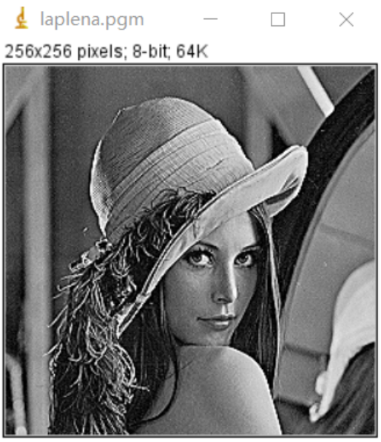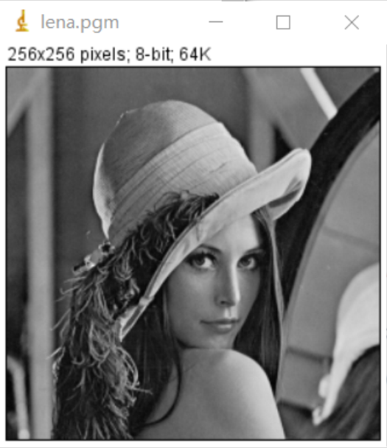

Result of processing “bridge.pgm”:

Source Image: Result after image sharpen:

(Laplacian)

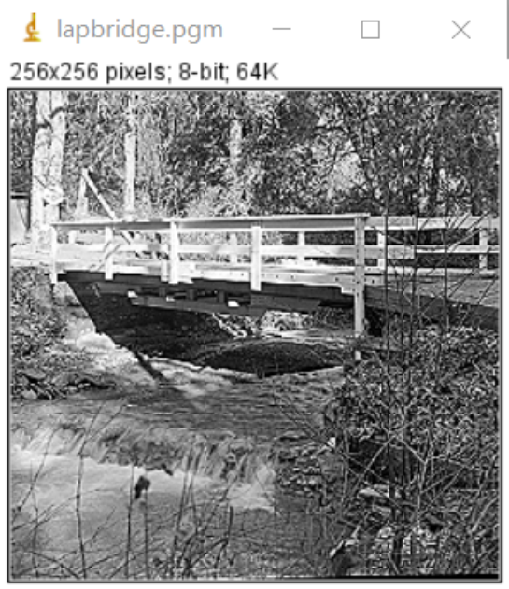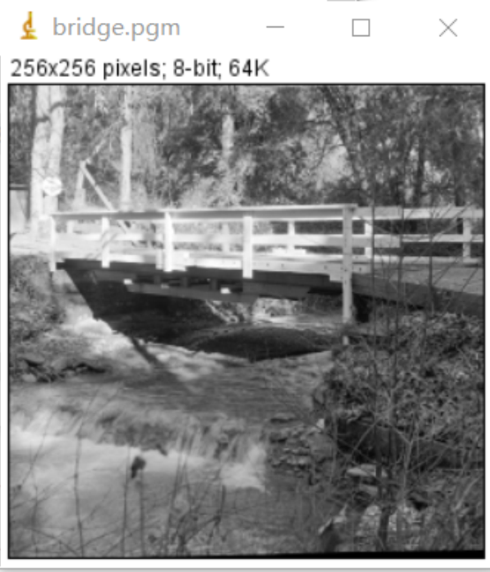

**Discussion:**

Since Laplacian is a differential operator, its application can enhance the region of sudden grayscale changes in the image and weaken the slowly changing regions of grayscale. Therefore, the sharpening process can select the Laplacian operator to process the original image to generate an image describing the gray level mutation, and then superimpose the Laplacian image with the original image to generate a sharpened image.

**Codes:** 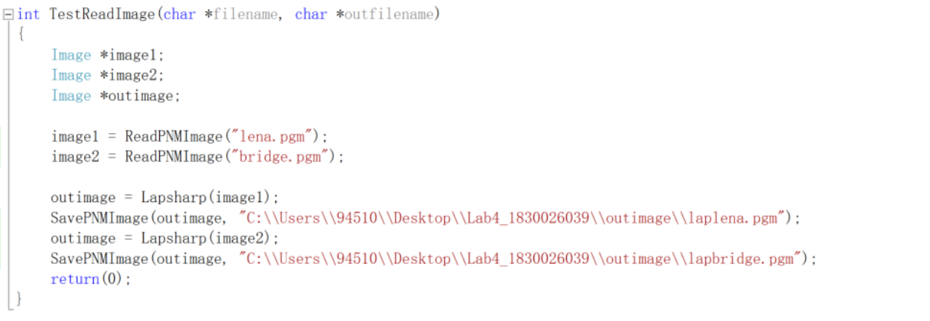 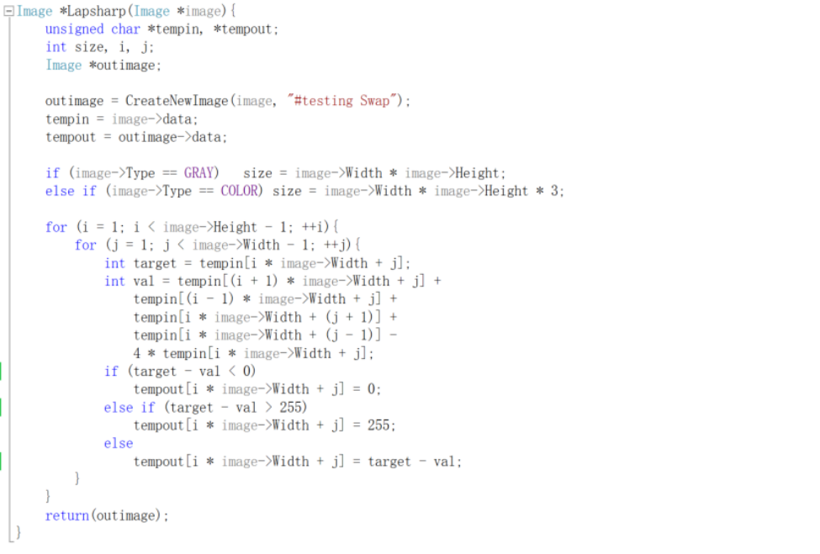

* Sobel

**Algorithm:**

Sobel Convolution factor:

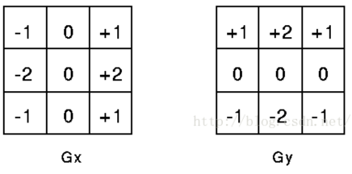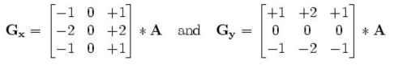

The specific calculation is as follows:

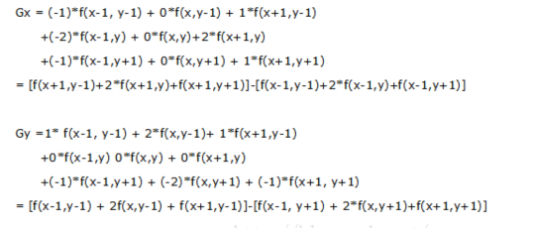

Where f (a, b) represents the gray value of the image (a, b) point

The horizontal and vertical gray values of each pixel of the image are combined by the following formula to calculate the gray scale of the point:

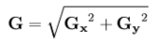

**Results (including pictures):**

Result of processing “Lena.pgm”:

Source Image: Result after image sharpen:

(Sobel)

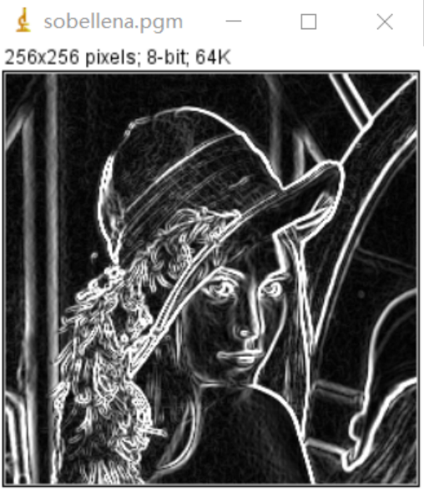

Result of processing “bridge.pgm”:

Source Image: Result after image sharpen

(Sobel)

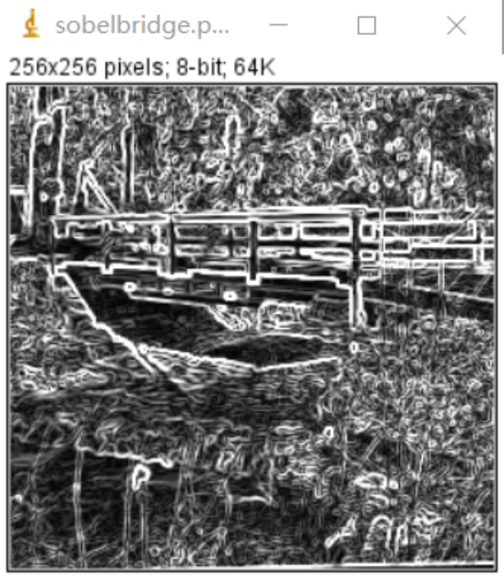

**Discussion:**

The Sobel operator is mainly used for edge detection. Technically, it is a discrete difference operator that is used to calculate the approximate value of the gray level of the image brightness function. Using this operator at any point of the image will generate the corresponding gray vector or its normal vector. The Sobel operator detects the edge based on the gray-scale weighted difference between the upper and lower, left and right adjacent points of the pixel and reaches the extreme value at the edge. It has a smoothing effect on noise, provides more accurate edge direction information, and the edge positioning accuracy is not high enough. When the accuracy requirements are not very high, it is a more commonly used edge detection method.

**Codes:** 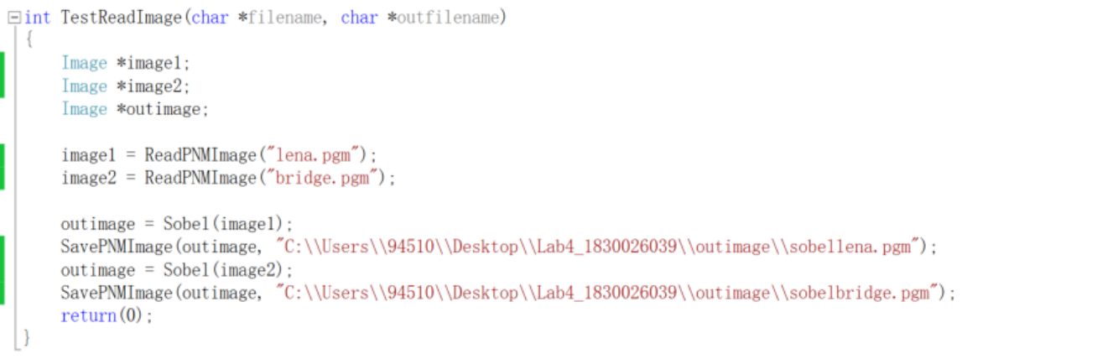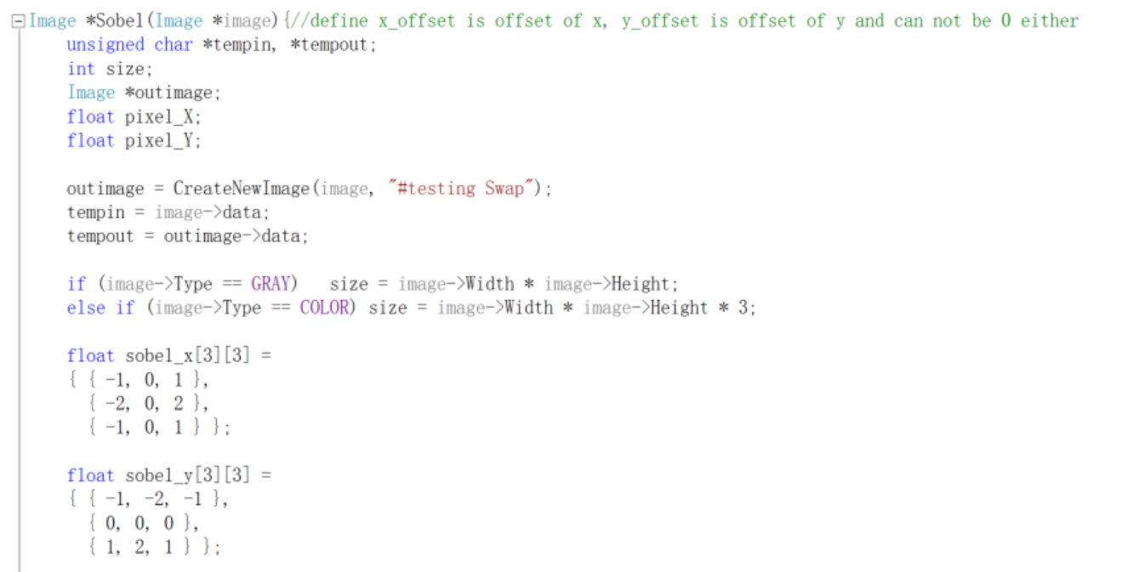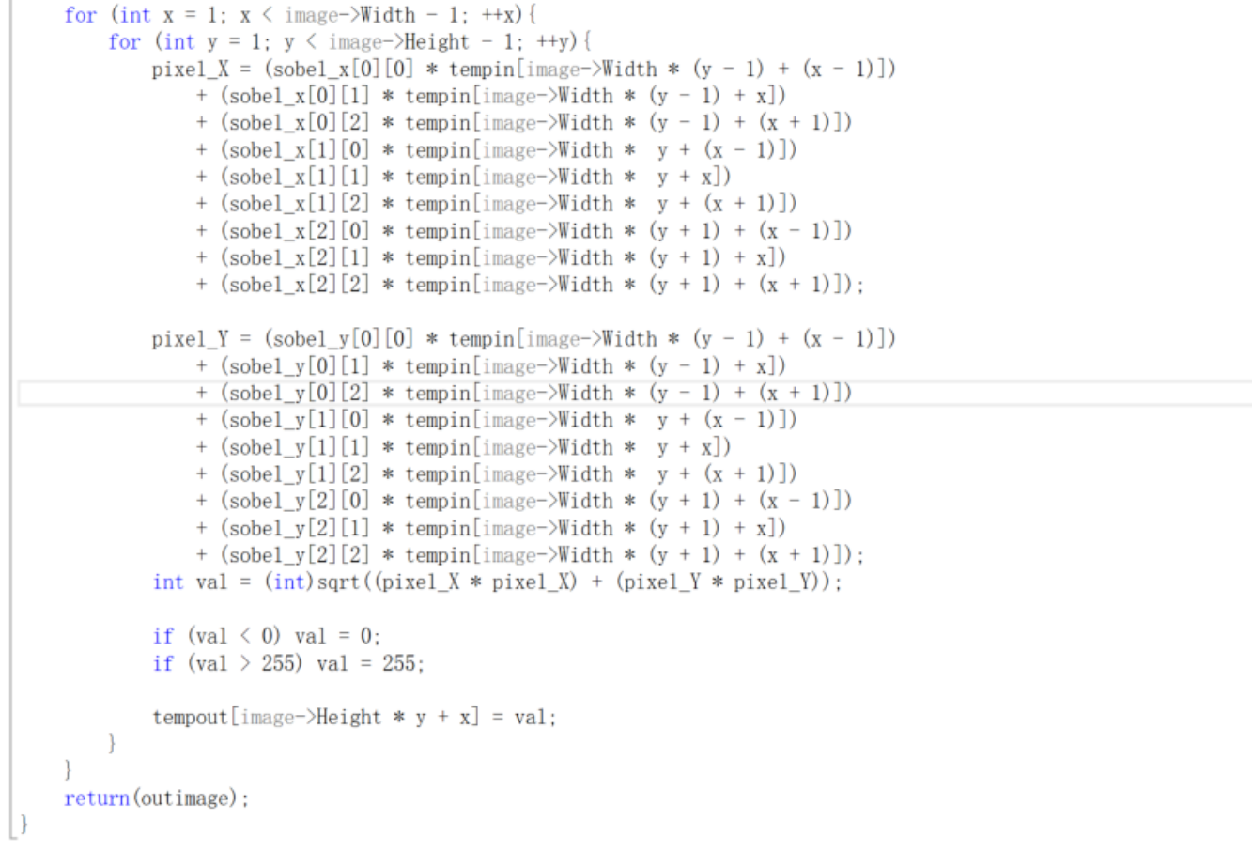

1. **Gamma correction (lena, bridge):**

**Algorithm:**

$$s=cr^{γ}$$

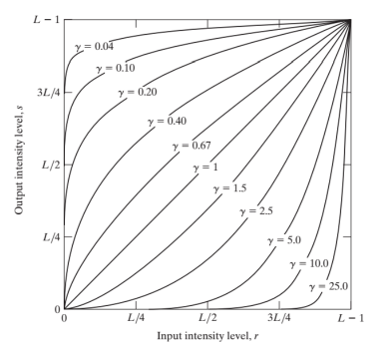We have a value of $γ$, such as 2.5, let c=1, and preprocess the image before inputting it to the monitor, that is, perform $s=r^{1/2.5}= r^{0.4}$ transformation.

i=0, i < imageheight, i plus 1

j = 0, j < imagewidth, j plus 1

let num mean the gamma value

$$let t={inimagedata[j][i]/255}^{1/num}$$

$outimagedata=t$

Then calculate the variances of the out image:

(size means imageheight * imagewidth)

$average=plus all t then divided by size$

i=0, i < imageheight, i plus 1

j = 0, j < imagewidth, j plus 1

var means the variances,

${var+=(inimagedata\left[j\right]\left[i\right]-averange)}^{2}/size$

**Results (including pictures):**

Result of processing “Lena.pgm”:

Source Image: Result after Gamma correction:

(1.0)

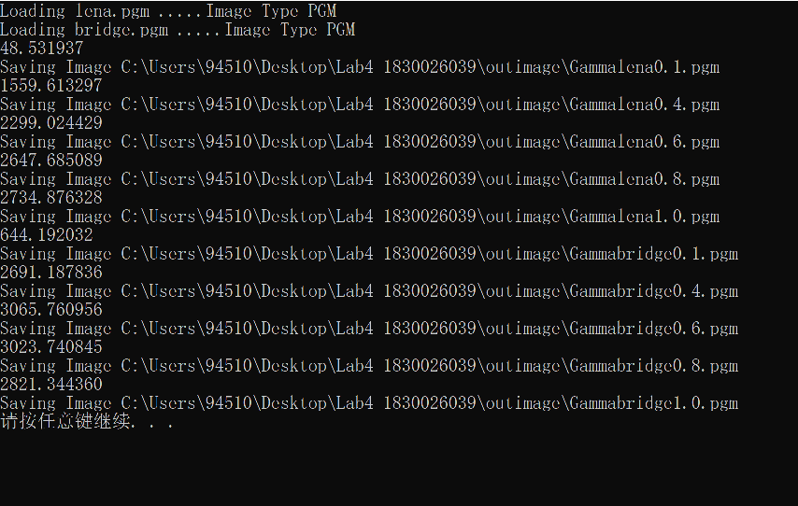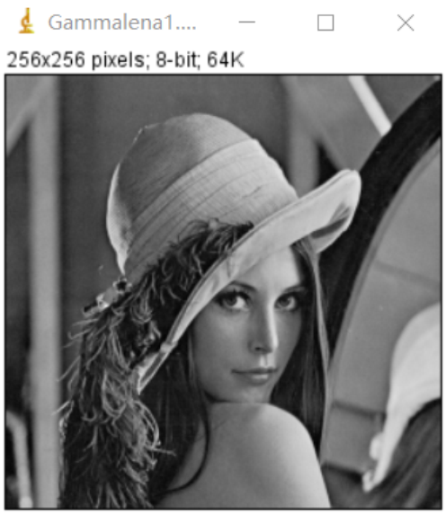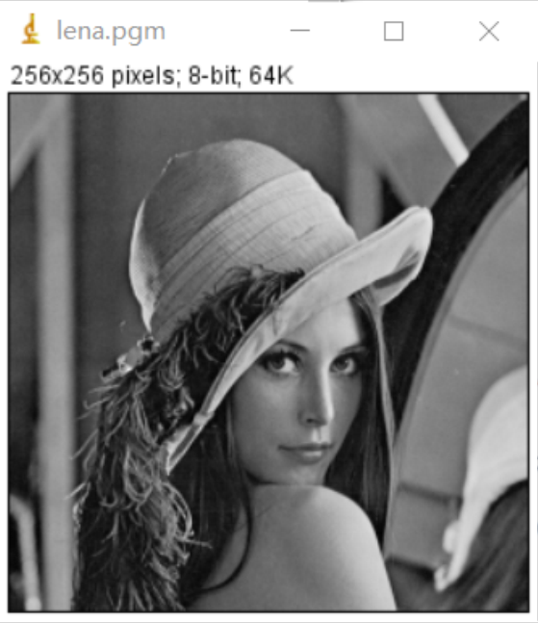

Result after Gamma correction:

(0.8) Result after Gamma correction

(0.6)

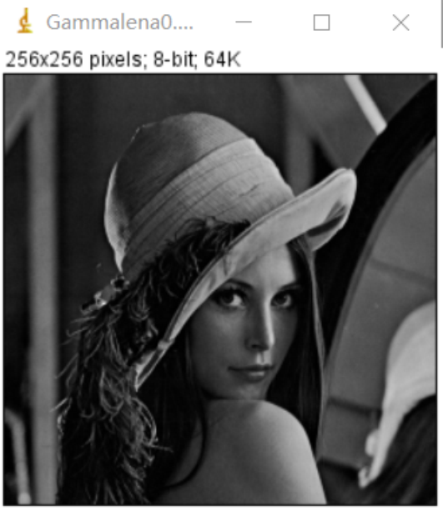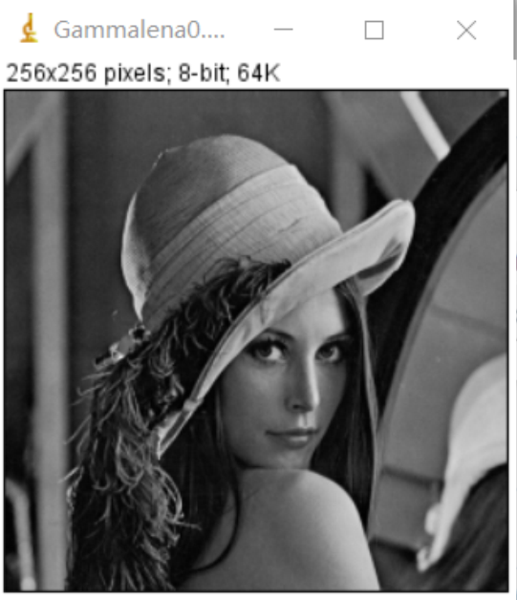

Result after Gamma correction:

(0.4) Result after Gamma correction

(0.1)

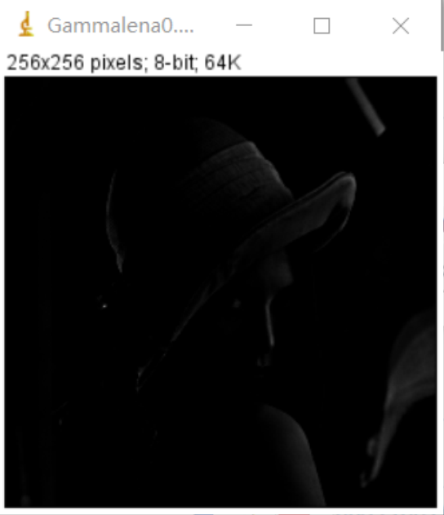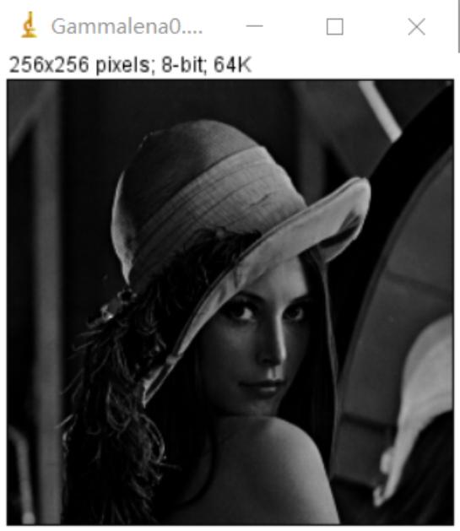

Result of processing “bridge.pgm”:

Source Image: Result after Gamma correction:

(1.0)

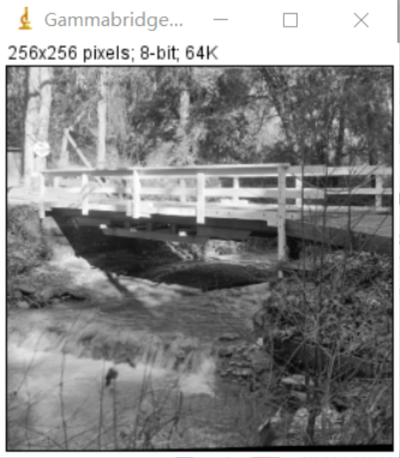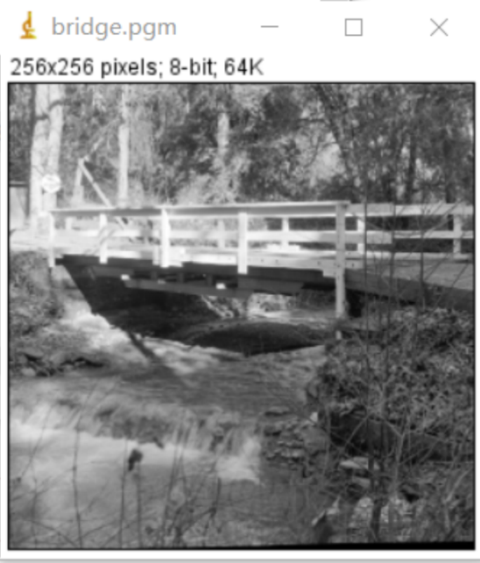

Result after Gamma correction:

(0.8) Result after Gamma correction

(0.6)

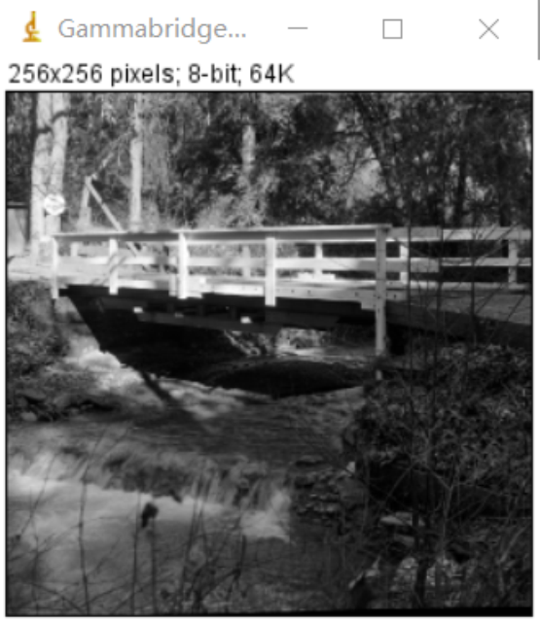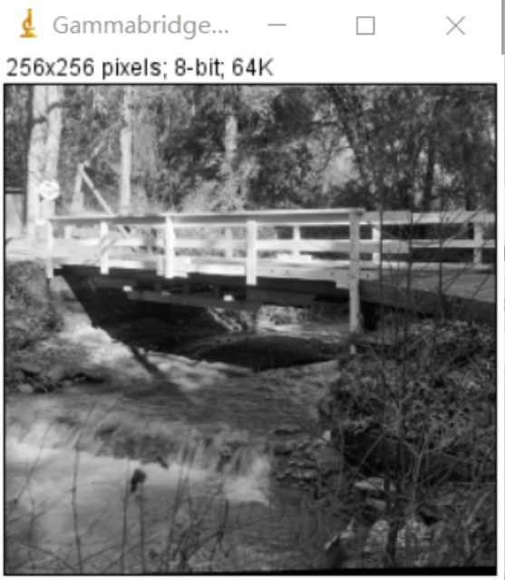



Result after Gamma correction:

(0.4) Result after Gamma correction

(0.1)

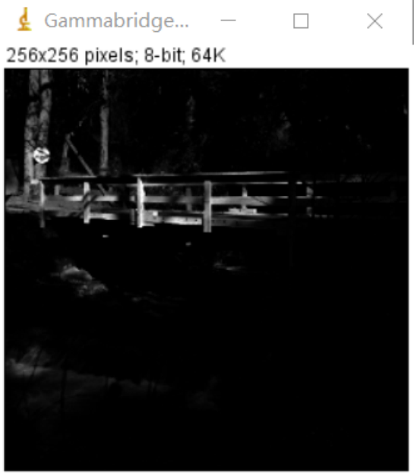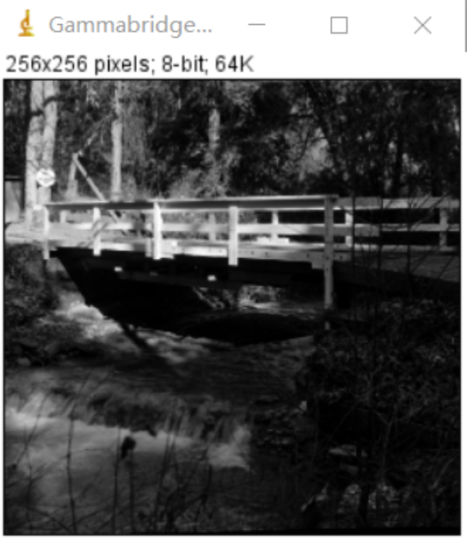



**Discussion:**

The so-called gamma correction is to edit the gamma curve of the image to perform non-linear tone editing on the image to detect the dark part and light part in the image signal and increase the ratio of the two to improve the image Contrast effect. In practical applications, we can adjust the gamma value within a certain range according to the actual situation to obtain the best effect.

**Codes:** 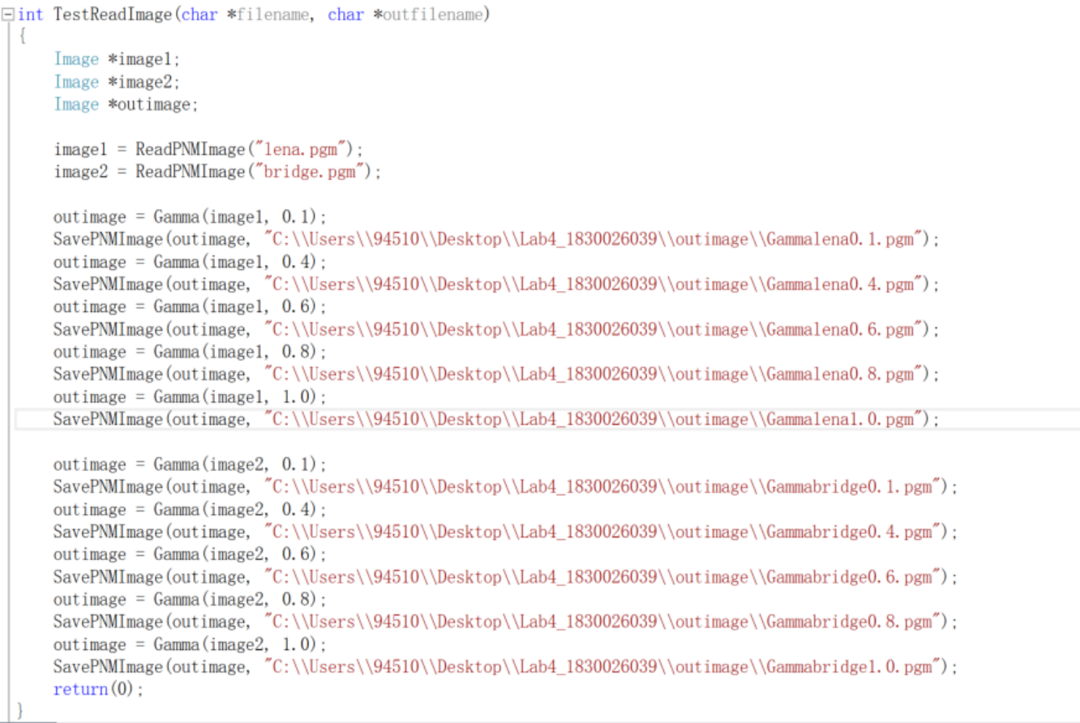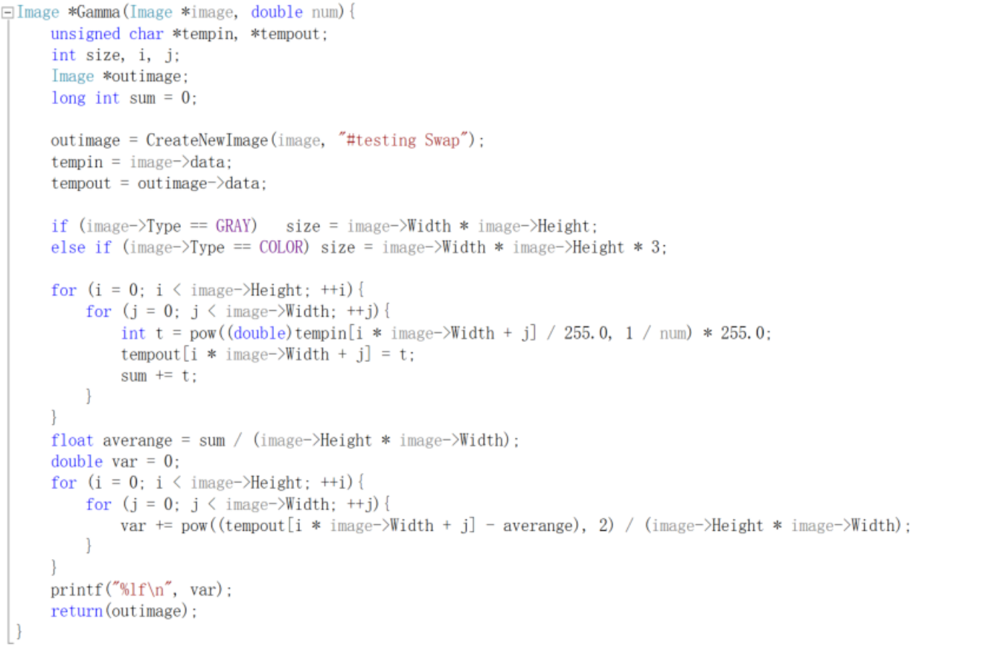

1. **histogram enhancement (lena, bridge):**

* Global

**Algorism**

Assume that the gray level before transformation is X, and the gray level after transformation is Y. To make the histogram of the image (approximately) uniform, then we must find a monotonic mapping f: R->R. This monotonic mapping satisfies $Y+∆Y=F(X+∆X)$. After theoretical deduction (the specific process is omitted here), we find that the ideal mapping happens to be the Cumulative Distribution Function (CDF).

Suppose the number of gray in the image is $x$ is $n(x)$, and the total number of pixels is $N$; for each gray value in the image, the corresponding cumulative distribution function calculation formula is:

$$f\left(x\right)=\frac{\sum_{0}^{x}{n(x)}}{N}$$

**Results (including pictures):**

Result of processing “Lena.pgm”:

Source Image: Result after global histogram enhancement:

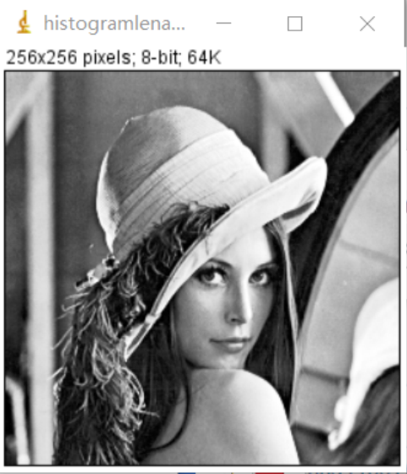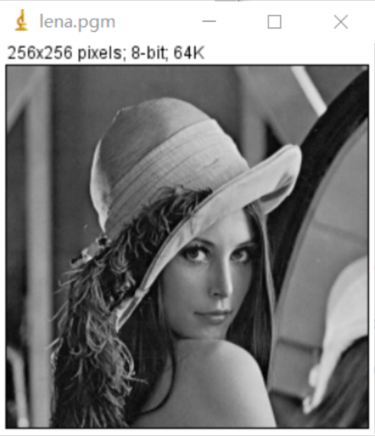

Result of processing “bridge.pgm”:

Source Image: Result after global histogram enhancement:

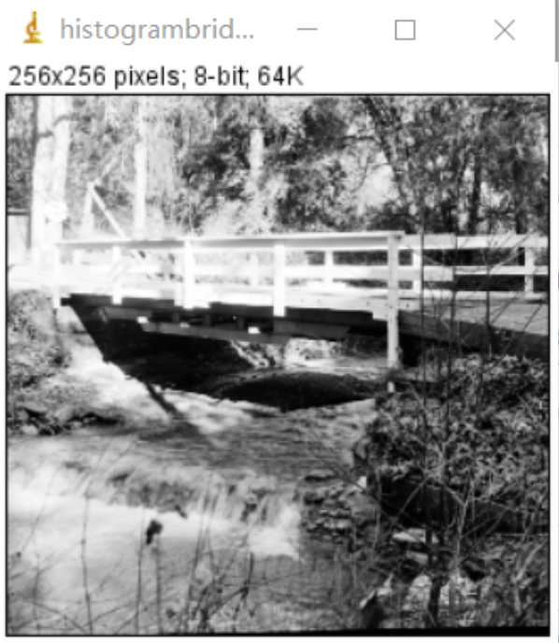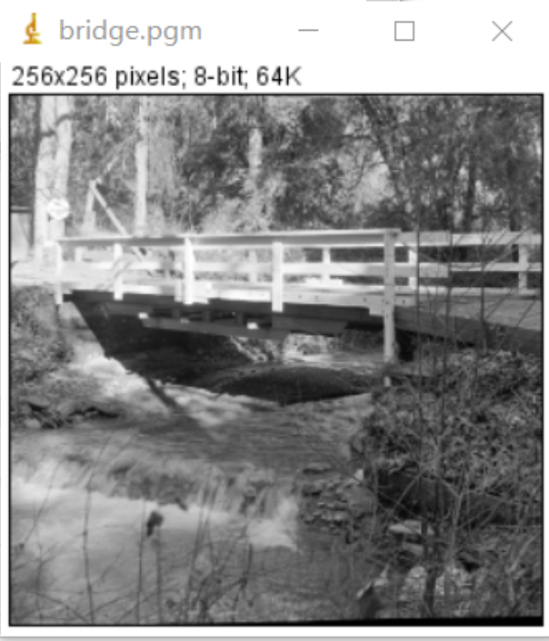

**Discussion:**

Histogram Equalization is a method of enhancing image contrast. Its main idea is to change the histogram distribution of an image into an approximately uniform distribution, thereby enhancing the contrast of the image. Although histogram equalization is only a basic method in digital image processing, its function is very powerful and it is a very classic algorithm.

**Codes:**

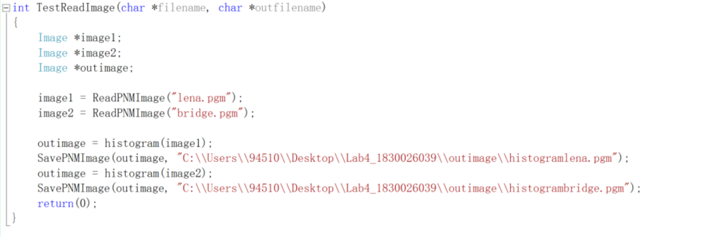

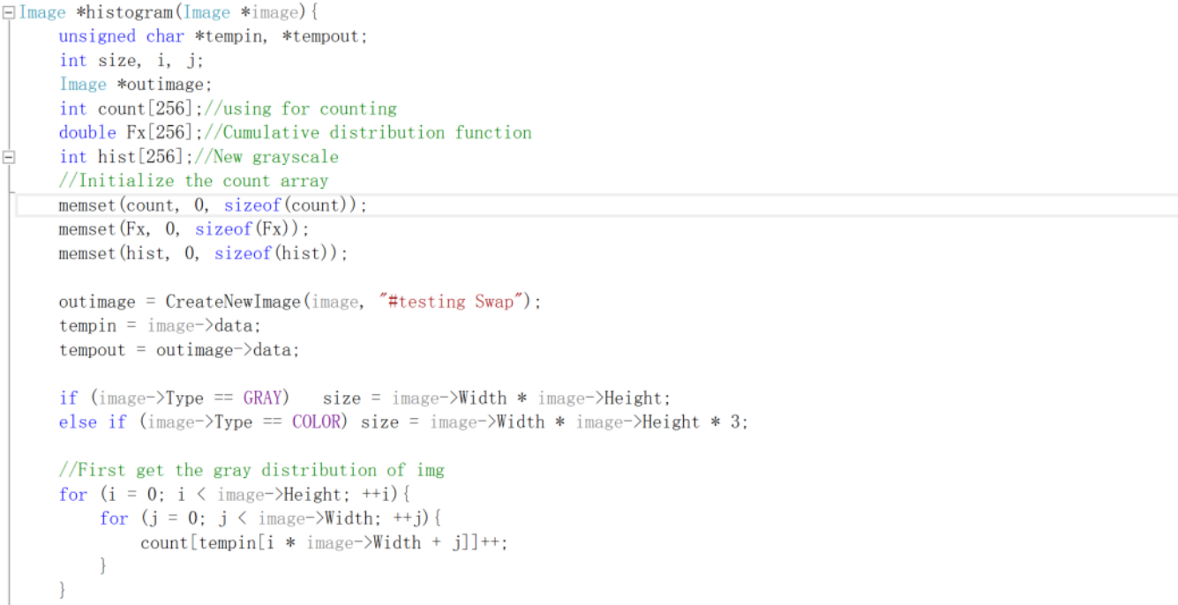 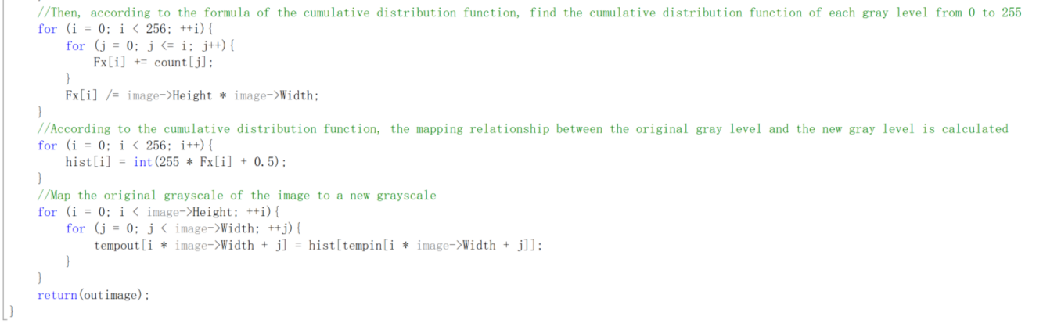

* Local

**Algorithm:**

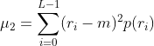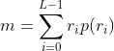

Image mean formula: Image variance formula:

In the formula of L-1, L is the number of grayscale levels or brightness levels of the image. If it is an 8-bit image, L is 256, and ri is the brightness level. p(ri) is the ratio of the current brightness level to the entire image, or The probability of occurrence of ri. Among them, p(ri) can be obtained from the histogram of the image.

k0, k1, k2 are the parameters that we can adjust in the process of processing the image.

**Results (including pictures):**

Result of processing “Lena.pgm”:

Source Image: Result after local histogram enhancement:

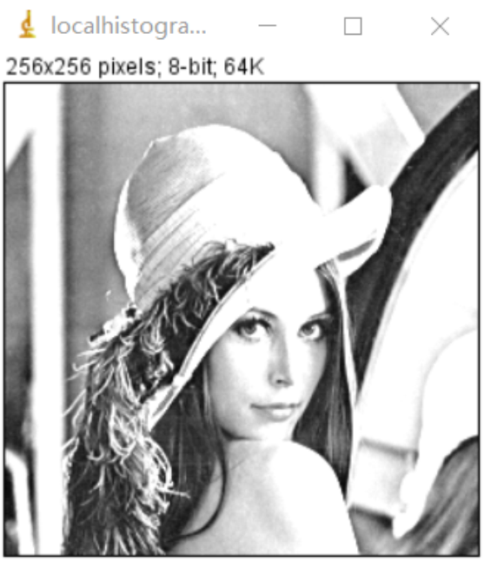

Result of processing “bridge.pgm”:

Source Image: Result after local histogram enhancement:

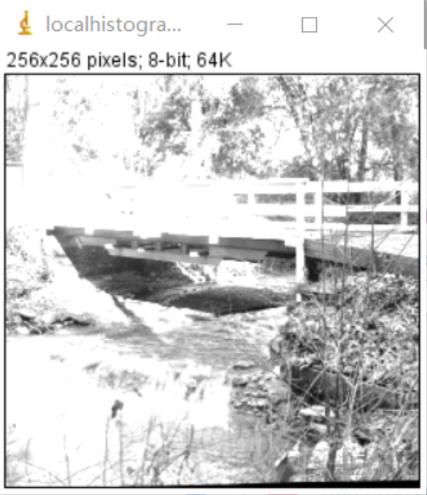

**Discussion:**

The global histogram equalization processing can indeed improve the dynamic range and contrast of the image, but in some cases, it is different, and the image processed by the local histogram can restore some of the dark details that are not visible in the original image.

The basic idea of local histogram processing is to use templates of different sizes to slide and compare the mean and variance of the entire image with the mean and variance of the local template (block) in the image. If it meets the requirements, select the center of the template as a suitable candidate Point, multiply the brightness of the candidate point by a constant E. The average brightness of an image reflects the average brightness of the image, and the variance reflects the overall contrast of the image. The greater the variance, the stronger the contrast.

**Codes:**

 